Name: | ___________________________________________________ |  | Date: ___________
 | Year 10 Mathematics  Investigation 2, 2015  Topic – Linear Functions  In class component |  | 56  = %
Total Time: | 60 minutes
Weighting: | ______% of the year.
Equipment: | Scientific Calculator, Take Home Component
AIM: In this assessment, you will be investigating parallel and perpendicular linear functions.
Take Home Component: 10 marks

1. | [2 marks]
 | Write two rules about the relationship between the equations or graphs and the gradients of linear functions. Hint: Refer to your take home component.

2. | [4 marks: 2, 2]
a) | Which of the following are parallel to 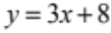 ? Circle the correct answer(s).
 | 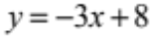 | 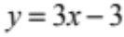
 | 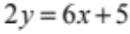 | 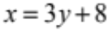
b) | Which of the following are perpendicular to 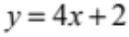 ? Circle the correct answer(s).
 | 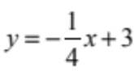 | 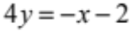
 | 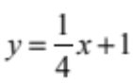 | 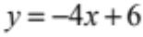

3. | [18 marks: 8, 8, 1, 1]
a) | For each equation given below, complete the table of values.
i) | 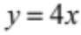 | ii) | 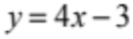
  x | –2 | –1 | 0 | 1 | 2
  y
  x | –2 | –1 | 0 | 1 | 2
  y
iii) | 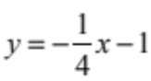 | iv) | 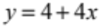
  x | –4 | –2 | 0 | 2 | 4
  y
  x | –2 | –1 | 0 | 1 | 2
  y
b) | Graph the linear functions from part a) on the same set of axes below.
 | 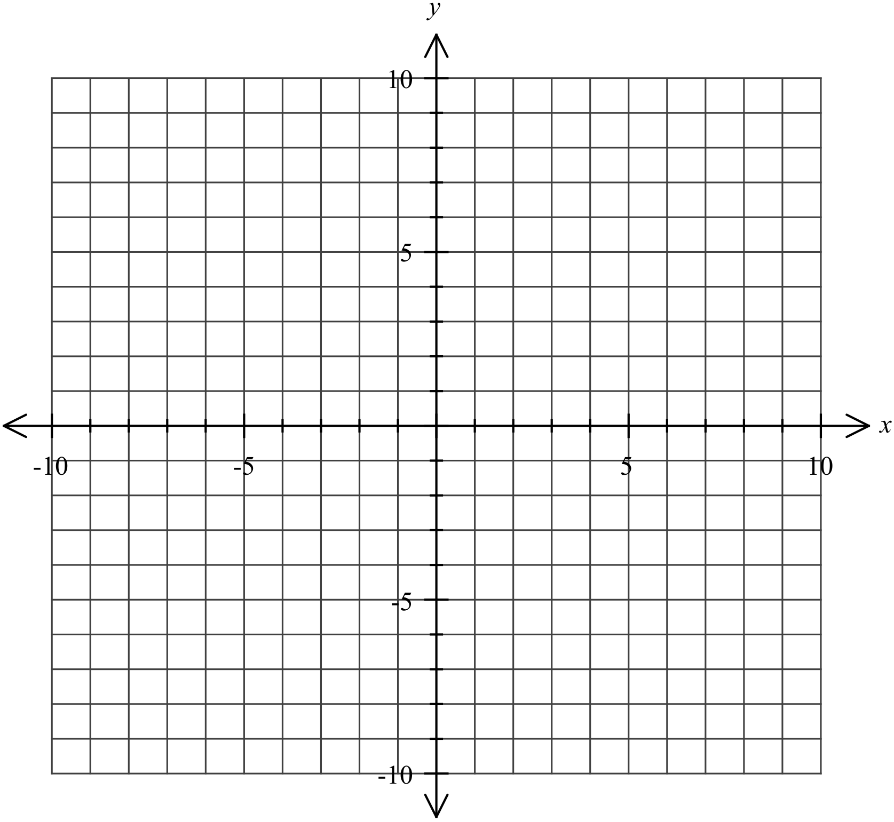
c) | Which lines are parallel?
d) | Name one pair of lines that are parallel.

4. | [8 marks: 4, 4]
a) | 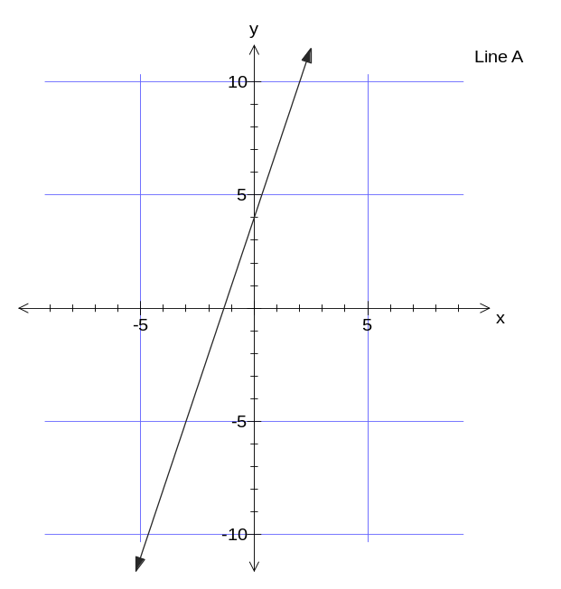 | What is the equation of line A?  Write the equation of a line which is parallel to line A.
b) | 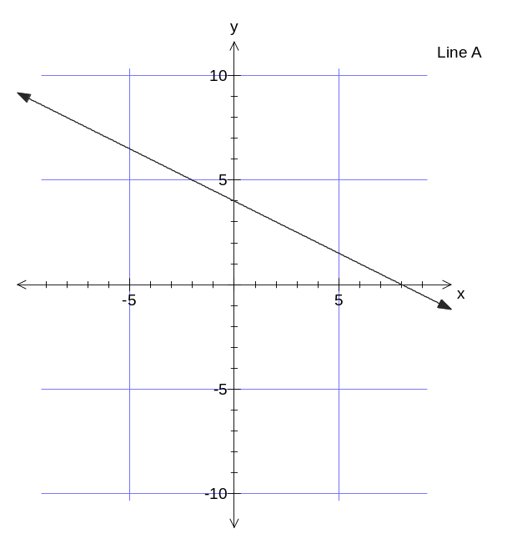 | What is the equation of line A?  Write the equation of a line which is perpendicular to line A.

5. | [4 marks: 2, 2]
a) | What is the equation of the line that is parallel to 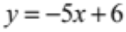 and crosses the y axis at (0,4)
b) | What is the equation of the line that is perpendicular to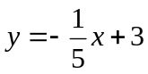 and crosses the y axis at (0,4).

6. | [10 marks]
 | The diagram below shows 8 lines, labelled A to H.
 | 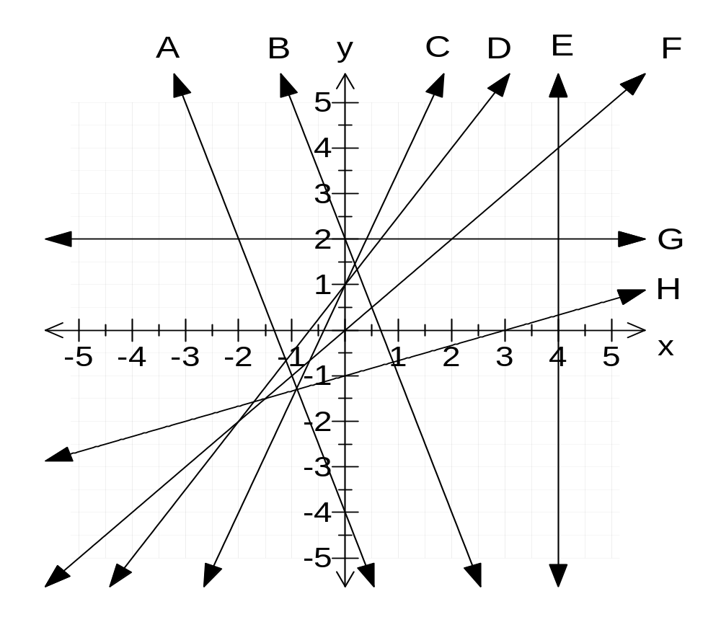
 | Determine which of these lines satisfy the following properties. In some cases, there will be more than one answer; include all cases.
a) | Line(s) which are parallel
b) | Line(s) which have a positive gradient
c) | Line(s) which pass through the origin
d) | Line(s) with an x-intercept of 3
e) | Line(s) with a y-intercept of 1
f) | Line(s) which intersect at (–2, 2)
g) | Line(s) which are perpendicular
h) | Vertical lines
i) | Line(s) with equation 